SCREENSHOT OF SYNTAX:
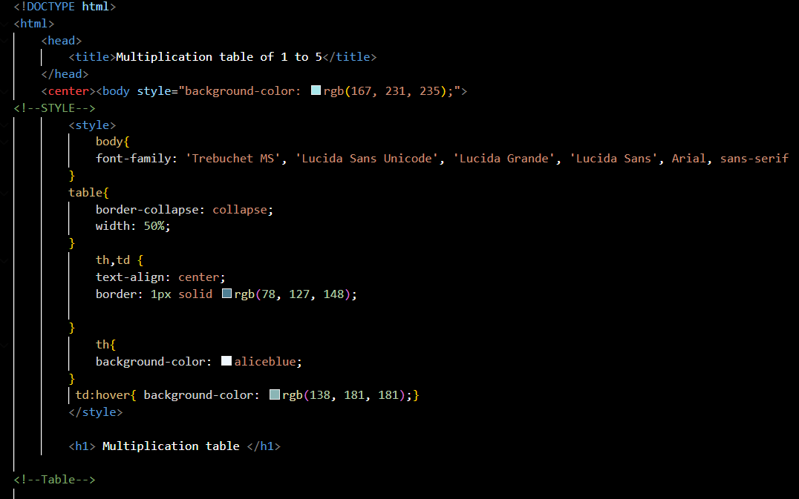
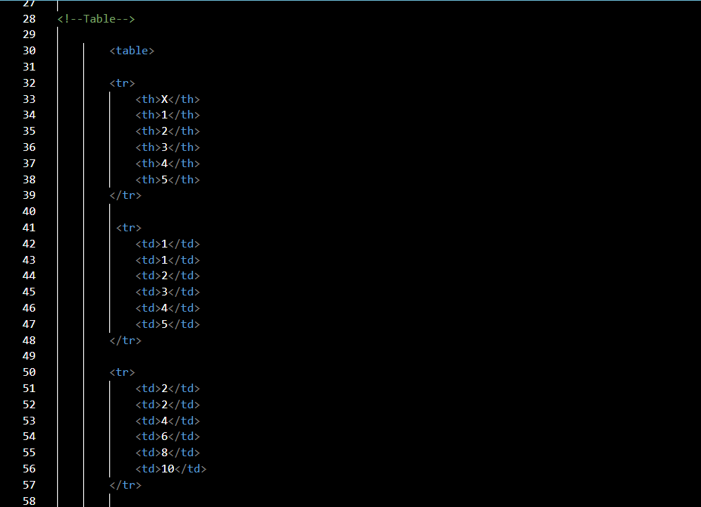
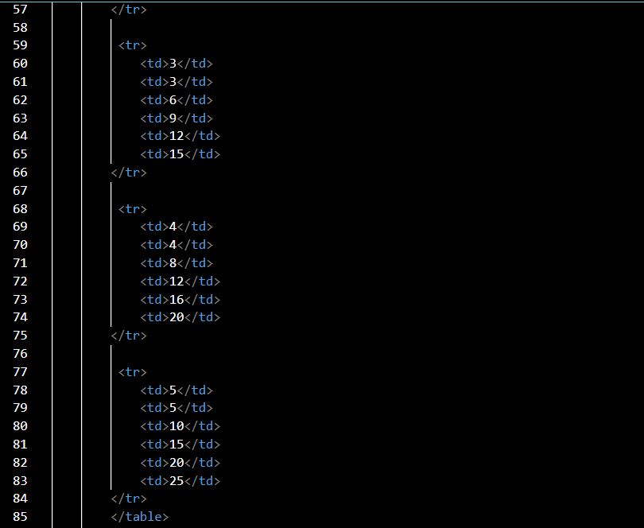
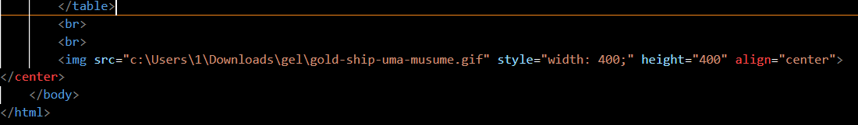

SCREENSHOT OF OUTPUT:
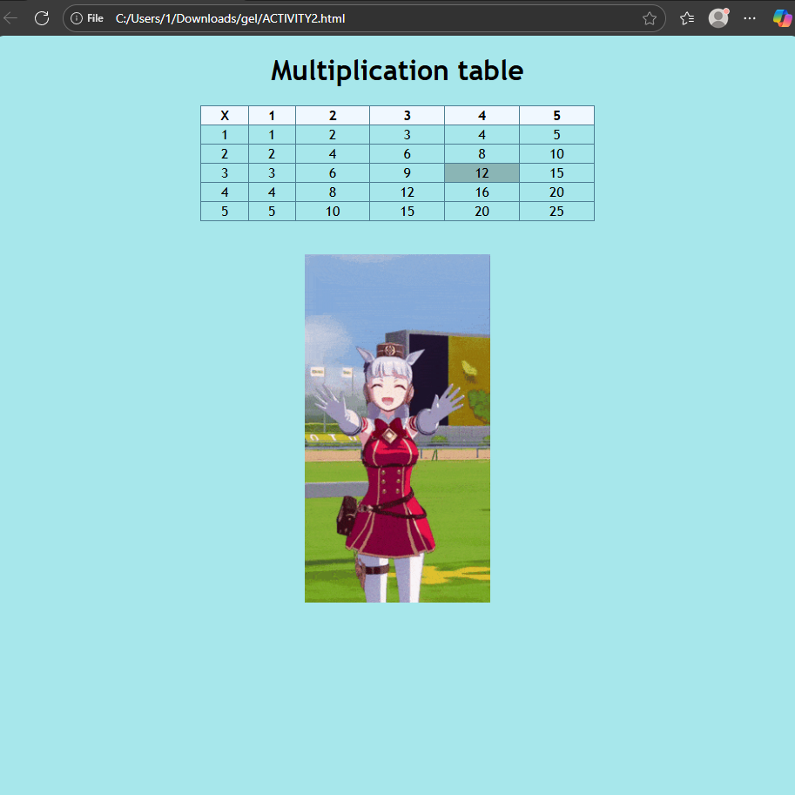

SCREENSHOT OF SYNTAX WITH PROVIDED EXPLANATION:

Here where the design of the output take place, also the style of the table

Here is the content of the output:

